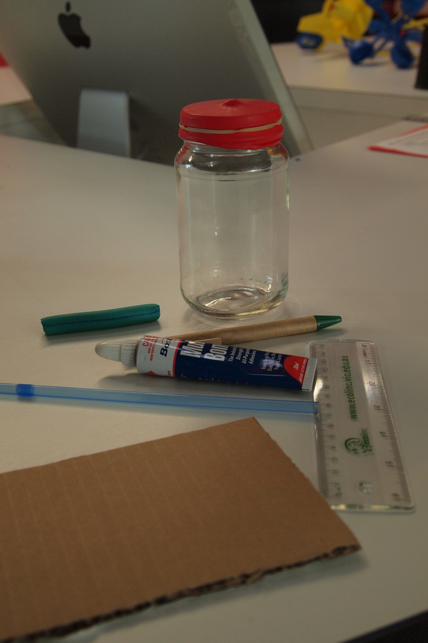**How to make a barometer to measure air pressure**

1. Introduction: You will learn how to make and use a barometer to measure air pressure.
2. Materials
   * Wide-mouth glass jar
   * Balloon
   * Rubber band
   * Scissors
   * Plastic straw
   * Cardboard
   * Glue
   * Ruler and pen
   * Modelling clay
   * Shoe-box sized cardboard box
3. Procedure
4. Cut the narrow opening of the balloon off.
5. Cover the top of the jar with the balloon so that it is airtight and use the rubber band to hold it in place. IMPORTANT: The seal should be airtight.
6. Place a small amount of glue in the middle of the balloon and carefully place the side of one end of the straw on the glue so that the other side extends over the edge of the jar.
7. While the glue is drying, fold a piece of cardboard so that it can stand on its own.
8. Carefully, make line 0.5cm apart and write ‘high pressure’ at the top and ‘low pressure’ at the bottom.
9. Once completed, place the barometer and the scale in the shoe-box so that the end of the straw with the clay reaches without touching the scale. Tape both the barometer and the scale into place so they cannot move.

**Use a barometer to measure air pressure**

1. Materials
   * Barometer
2. Procedure
3. Place the barometer in a shaded location free from temperature changes.
4. Wait a few minutes for the barometer to adjust to the current conditions.
5. Read the result from the scale (where the end of the straw measures on the scale) and record in the results table.
6. Continue checking the barometer twice a day (if possible).
7. Results: In your journal, draw up a table to record your results.
8. Discussion: Provide an explanation for the results. In your journal, answer the following:
   * Watch the video - [www.watchknow.org/Video.aspx?VideoID=8286&CategoryID=7316](http://www.watchknow.org/Video.aspx?VideoID=8286&CategoryID=7316)

What does a barometer measure?

* + Explain how the barometer works?
  + Complete a statement, which states the results from your findings. Such as ‘On May 6, 2011 at 10.00 am, it was clear and sunny and the air pressure was high. At 2.00 pm the weather turned cloudy and the air pressure was low.’
  + Are the results what you expected?

**Sample data table**

|  |  |  |  |
| --- | --- | --- | --- |
| **Date** | **Time** | **Weather conditions** | **Air pressure** |
| May 6, 2011 | 10.00 am | Clear and sunny | High pressure |
| May 6, 2011 | 2.00 pm | Cloudy with possibility of rain | Low pressure |