**How to make a rain gauge to measure precipitation**

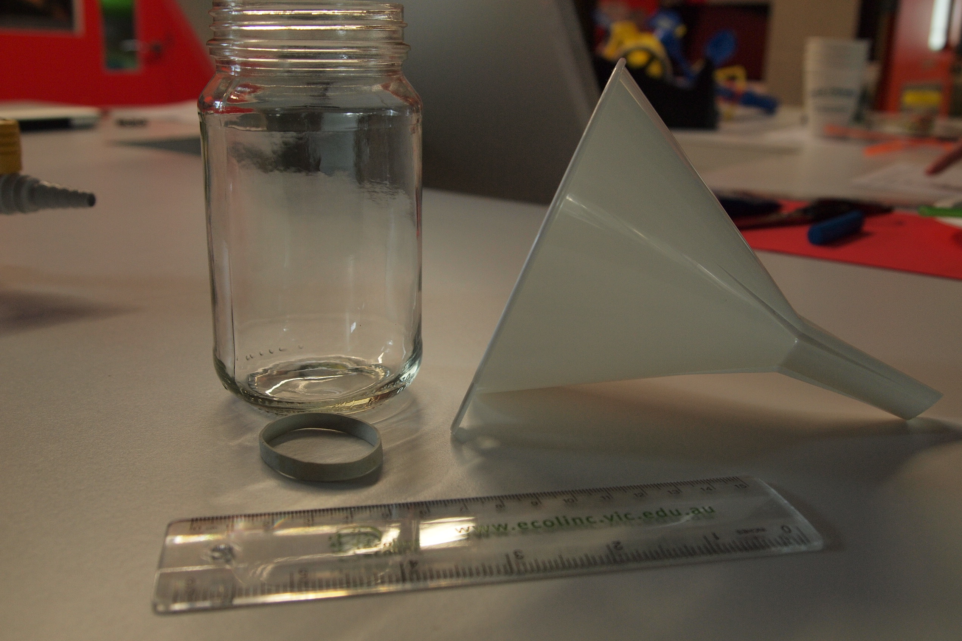

1. Introduction: You will learn how to make and use a rain gauge to measure precipitation.
2. Materials
   * Clear plastic ruler
   * Cylinder shaped clear jar
   * Rubber band
   * Funnel
   * Transparent tape
3. Procedure
4. Remove the jar’s label.
5. Attach the ruler to the outside of the jar with the rubber band; make sure the bottom edge if the ruler is even with the bottom of the jar. Or secure the ruler inside the jar so it is standing vertically with the end at the base of the jar. Tape the ruler in place so the numbers can be read from the outside of the jar.
6. Place the funnel in the top of the jar. The top end of the funnel should cover the entire mouth of the jar.

**Use a rain gauge to measure precipitation**

1. Materials
   * Rain gauge
2. Procedure
3. Go outside and put the rain gauge on a flat position. Note: the rain gauge should not be put under or near trees or too close to buildings.
4. When the rain has stopped, read the ruler to determine how much rain was collected.
5. Empty the rain gauge after each use.
6. Results: In your journal, draw up a table to record your results.
7. Discussion: Provide an explanation for the results. In your journal answer the following:
   * Rain is not the only form of precipitation. What are some other types? Write a definition for each.
   * Watch the video - [www.watchknowlearn.org/Video.aspx?VideoID=8283&CategoryID=2662](http://www.watchknowlearn.org/Video.aspx?VideoID=8283&CategoryID=2662)
   * Explain how the rain gauge works?
   * Complete a statement, which states the results from your findings. Such as ‘On May 23, 2011 there was quite a lot of rain and drizzle. In total, 5.5 mm fell.’
   * Are the results what you expected?

**Sample data table**

|  |  |  |  |
| --- | --- | --- | --- |
| **Date** | **Type of precipitation (rain, drizzle, snow, sleet, hail)** | **Precipitation (mm)** | **Precipitation daily total (mm)** |
| May 23, 2011 | Rain and drizzle | 3.0, 2.5 | 5.5 |