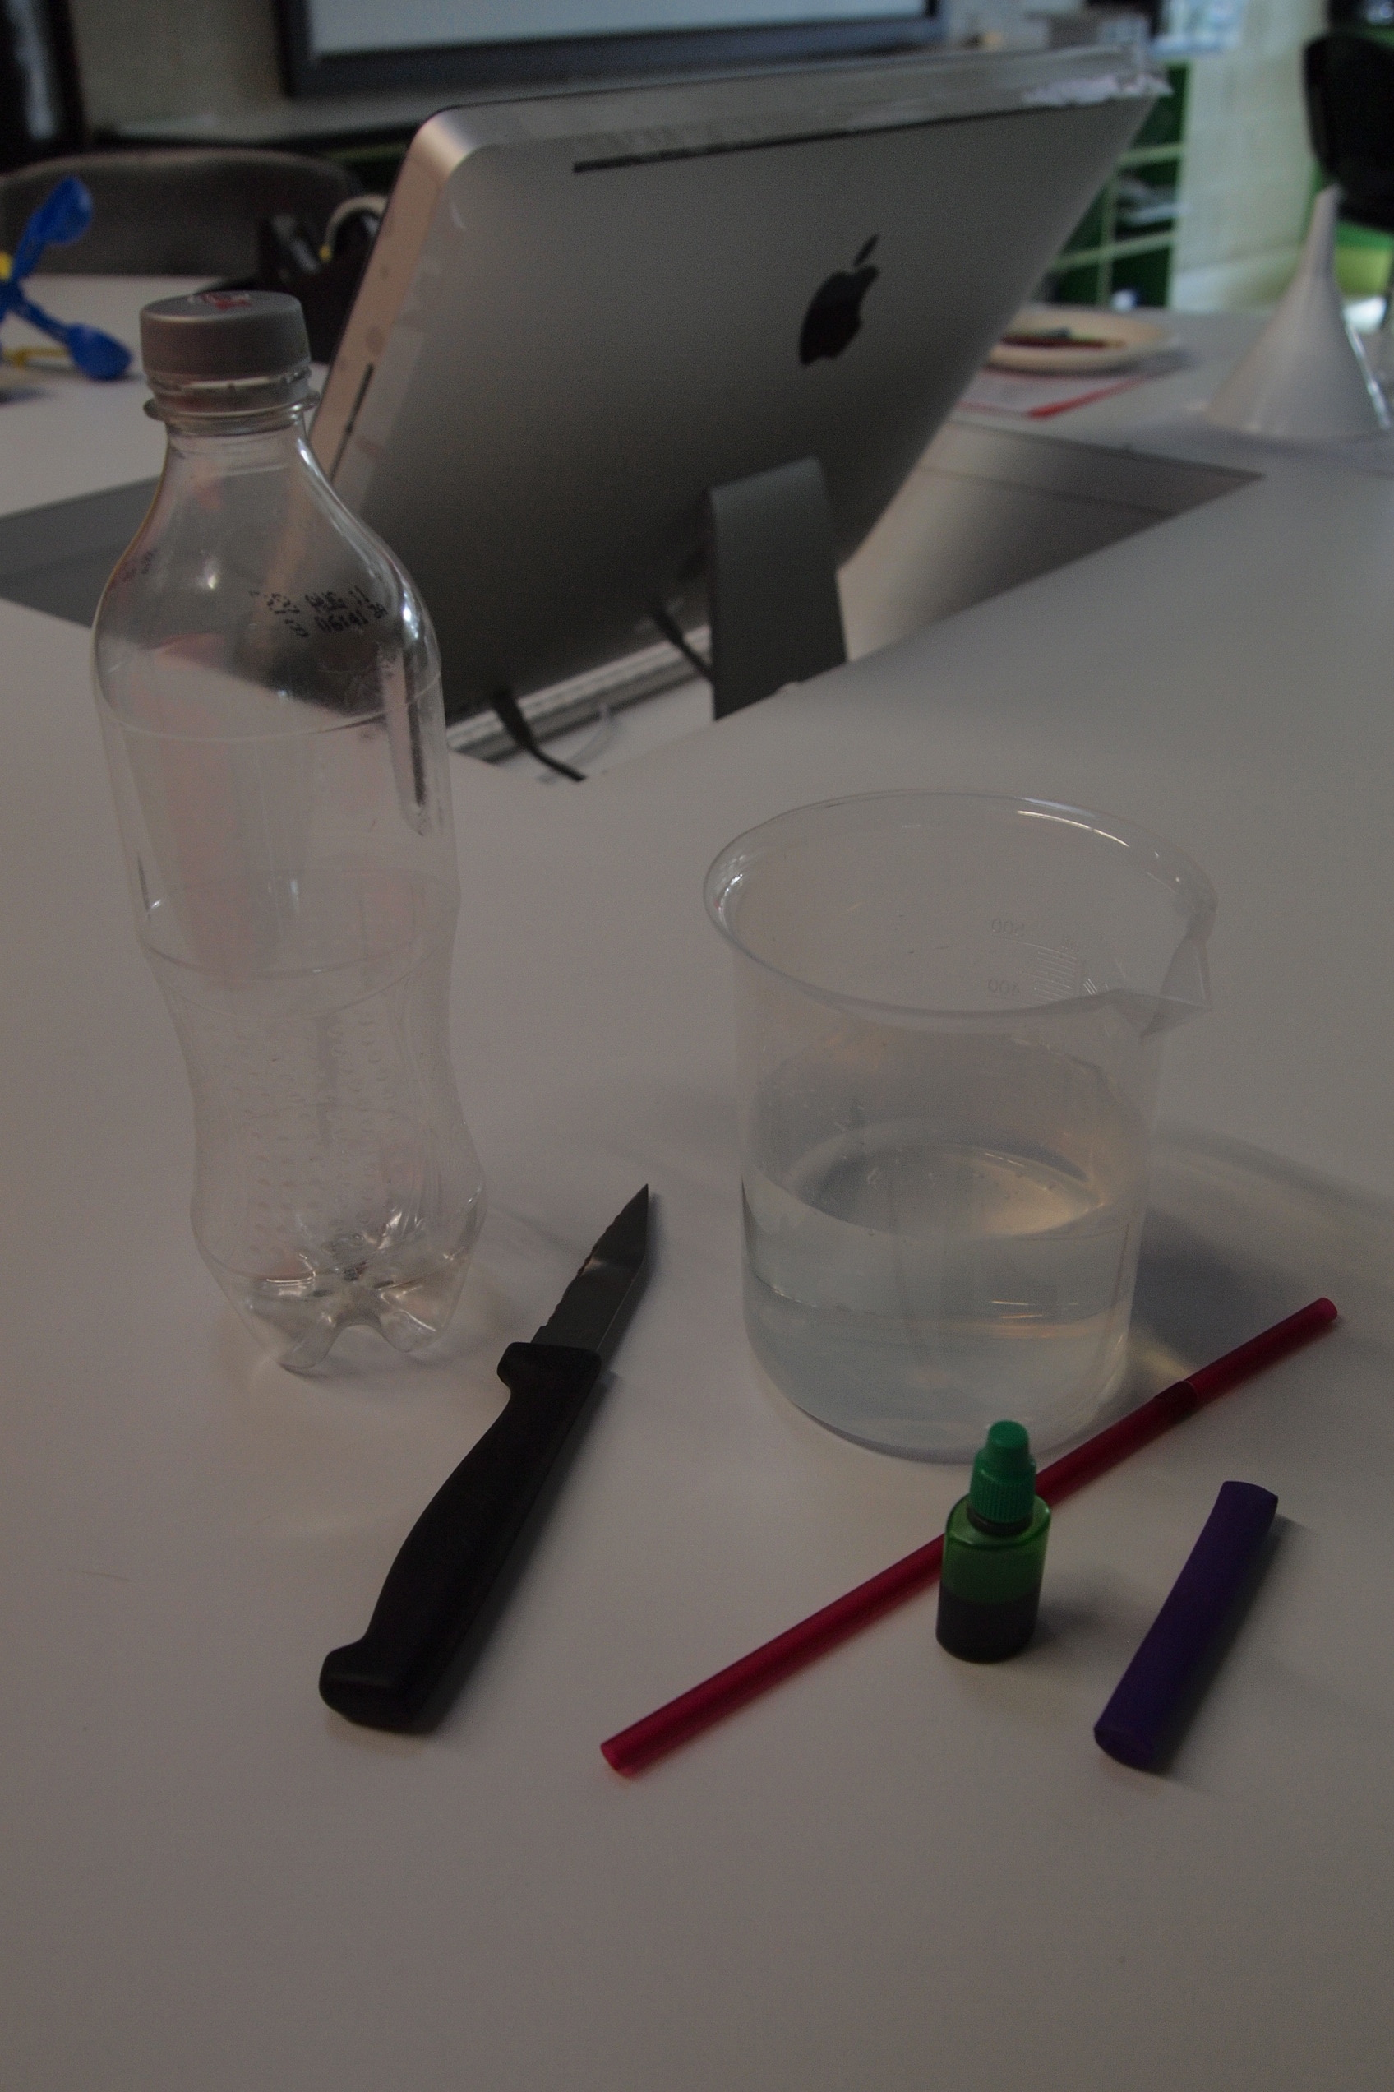**How to make a thermometer to measure temperature**

1. Introduction: You will learn how a thermometer works by making it however you will need a commercial thermometer to record the actual temperature.
2. Materials
   * Small clear plastic bottle (remove all labels)
   * Knife – ensure this is used with teacher supervision
   * Water
   * Clear plastic drinking straw
   * Food colouring
   * Modelling clay or plasticine
   * A bowl of warm water
   * A bowl of cold water
3. Procedure
4. Make a small hole in the lid of the bottle (just big enough to insert the straw).
5. Half fill the bottle with water.
6. Add three drops of food colouring to the water.
7. Close the lid.
8. Place the straw through the hole in the lid. Ensure the straw is submerged in the liquid but not touching the bottom of the bottle.
9. Seal the top of the bottle with the modelling clay/plasticine so that it has a tight seal and to ensure the straw stands upright.
10. Test your thermometer
    1. Grasp the bottle with your hands and hold for a few minutes. What happens? Note your observations.
    2. Place the thermometer in a bowl of warm water. What happens? Note your observations.
    3. Place the thermometer in a bowl of cold water. What happened? Note your observations.
11. Results: In your journal, draw pictures to explain your observations.
12. Discussion: Provide an explanation for the results. Answer the following in your journal.
    * Watch the following video - [www.watchknow.org/Video.aspx?VideoID=26866&CategoryID=7319](http://www.watchknow.org/Video.aspx?VideoID=26866&CategoryID=7319)
    * What happens to the liquid when it is heated?
    * What happens to the liquid when it is cooled?
    * How does this relate to a commercial thermometer?

**Use a thermometer to measure temperature**

1. Materials
   * Commercial thermometer
2. Procedure
3. Go outside a wait two minutes before you take a reading. This is to allow the thermometer to adjust to the outside temperature.
4. On your results table record the current date, time and weather conditions.
5. Hold the thermometer at eye level and take the reading.
6. Take several readings and determine the average.
7. Results: In your journal draw up a table and record your results.
8. Discussion: Provide an explanation for the results. Answer the following in your journal:

* Complete a statement, which states the results from your findings. Such as ‘On May 1, 2011 at 10.00 am, it was cloudy and the temperature was 16.5°C. By 2.00 pm it was sunny and the temperature increased to 20.1°C.’
* Are the results what you expected?

**Sample data table**

|  |  |  |  |
| --- | --- | --- | --- |
| **Date** | **Time** | **Weather conditions** | **Temperature (°C)** |
| May 1, 2011 | 10.00 am | Cloudy | 16.5 |
| May 1, 2011 | 2.00 pm | Clear and sunny | 20.1 |