**How to make a wind vane to determine wind direction**

1. 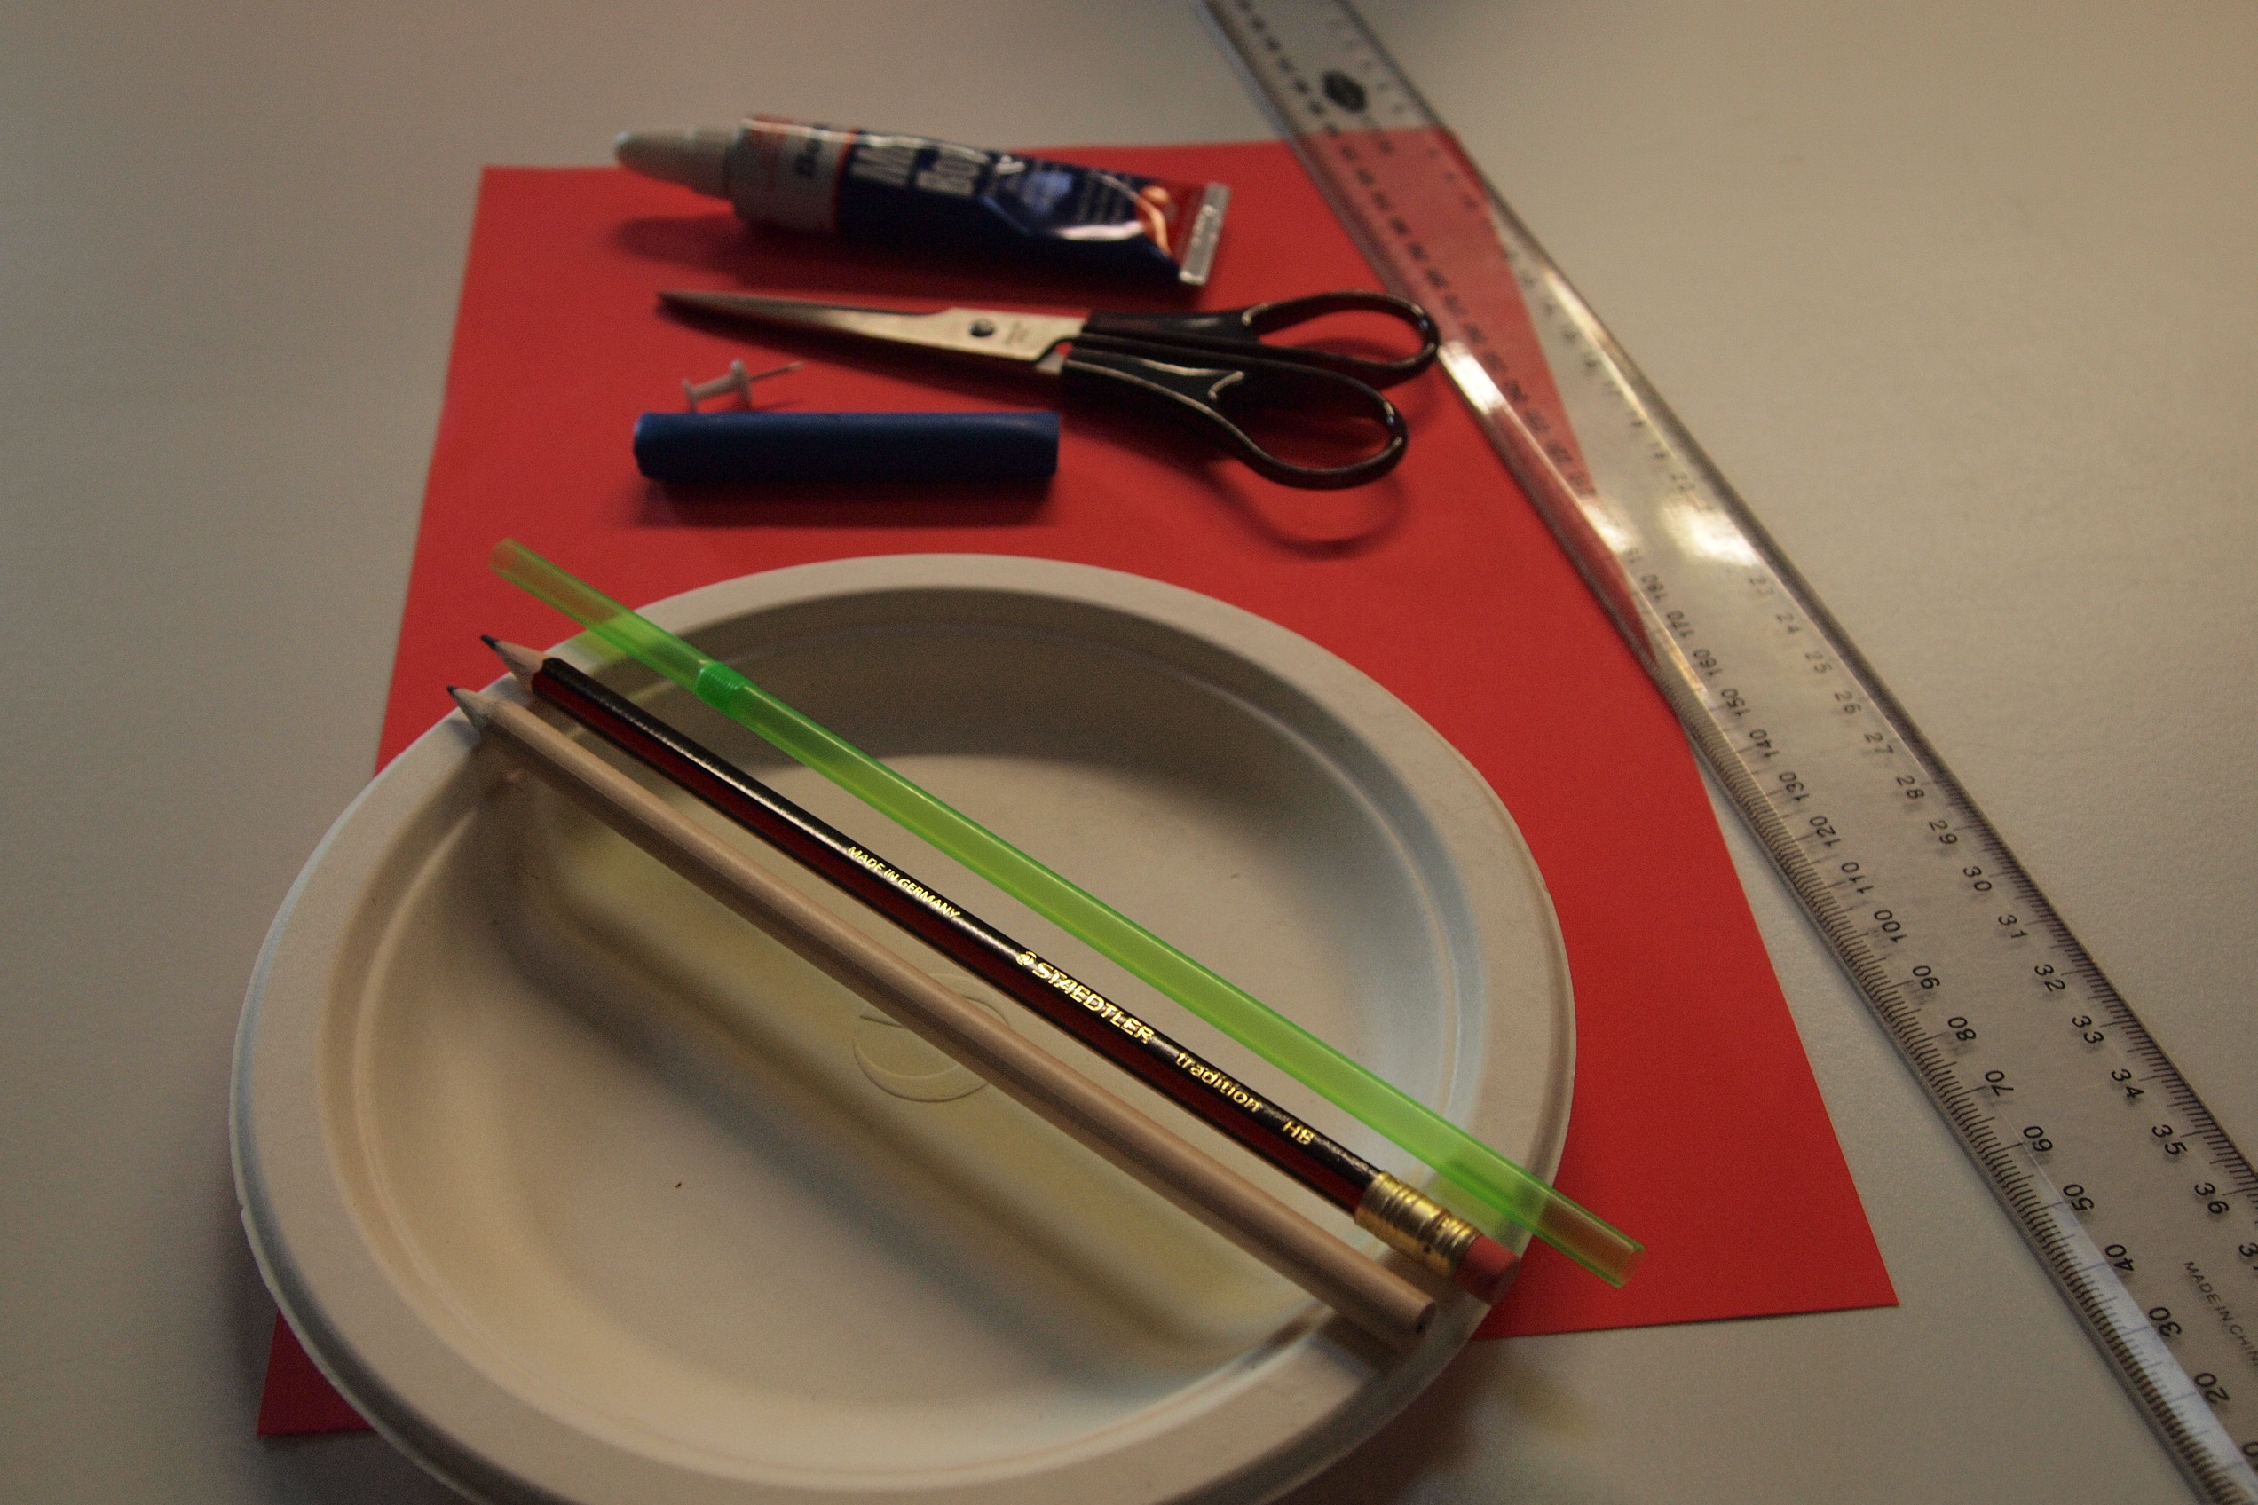Introduction: You will learn how to make and use a wind vane to determine wind direction.
2. Materials
   * Manila file folder
   * Ruler
   * Pencil
   * Scissors
   * Plastic drinking straw
   * Straight pin
   * Pencil with a new eraser
   * Modelling clay
   * Glue
   * Paper plate
3. Procedure
4. Draw an arrow 5cm long on the manila file folder.
5. Draw an arrow tail 7cm long on the manila file folder.
6. Cut the arrow and arrow tail out.
7. Make two 1cm cuts at the end of each straw (opposite each other).
8. Slide the arrow point and the arrow tail into the cuts in the straw.
9. Push a straight pin through the middle of the straw and into the eraser end of the pencil.
10. Stick the sharp end of the pencil into a lump of modelling clay; this will be your base.
11. Mark north, east, south and west on the paper plate.
12. Put the clay on the paper plate.
13. Test you wind vane. Blow on the vane to ensure the arrow spins freely.

**Use a wind vane to measure wind direction**

1. Materials
   * Wind vane
   * Compass
2. Procedure
3. In your journal, draw a large compass on mark north, south, east and west.
4. Go outside to an open space. Avoid trees, hedges and buildings as these can influence wind direction.
5. Place the paper plate on a flat surface and put the wind vane on the plate.
6. Use a compass to show where north is. Set up your plate so it faces the right direction.
7. Observe the vane. If it is very breezy, one student should hold down the paper plate while another takes the direction reading. The arrow will point to the direction with wind is blowing.
8. Check the direction of the paper plate.
9. Results: In your journal, draw up a table to record your results.
10. Discussion: Provide an explanation for the results. In your journal answer the following:
    * Explain how the wind vane works.
    * Complete a statement, which states the results from your findings. Such as ‘On May 30, 2011 at 10.00 am, the wind was blowing from a northerly direction. At 2.00 pm, the wind continued to blow from a northerly direction.’
    * Did the wind direction change over the course of the day?
    * Does wind direction affect temperature?

**Sample data table**

|  |  |  |
| --- | --- | --- |
| **Date** | **Time** | **Wind direction** |
| May 30, 2011 | 10.00 am | North |
| May 30, 2011 | 2.00 pm | North |